Build a Tiny Database in Java
https://medium.com/javarevisited/build-a-tiny-database-in-java-ca6d3f06e115
Tinysql> SELECT A,B FROM T1 WHERE A=1;
+---+-------+
| a | b |
+---+-------+
| 1 | Alice |
| 2 | Bob |
+---+-------+
exit;
This code is a bare-minimum implementation designed for learning purposes. Basically, I would like information on the following:
- How the data is stored internally (i.e. how tables are represented, etc.)
- How the engine finds data that it needs (e.g. run a SELECT query)
- How data is inserted in a way that is fast and efficient

- How to store the data internally: you should have a data file containing your database objects and a caching mechanism to load the data in focus and some data around it into RAM assume you have a table, with some data, we would create a data format to convert this table into a binary file, by agreeing on the definition of a column delimiter and a row delimiter and make sure such pattern of delimiter is never used in your data itself. i.e. if you have selected <*> for example to separate columns, you should validate the data you are placing in this table not to contain this pattern. you could also use a row header and a column header by specifying size of row and some internal indexing number to speed up your search, and at the start of each column to have the length of this column like "Adam", 1, 11.1, "123 ABC Street POBox 456" you can have it like <&RowHeader, 1><&Col1,CHR, 4>Adam<&Col2, num,1,0>1<&Col3, Num,2,1>111<&Col4, CHR, 24>123 ABC Street POBox 456<&RowTrailer>
- How to find items quickly try using hashing and indexing to point at data stored and cached based on different criteria taking same example above, you could sort the value of the first column and store it in a separate object pointing at row id of items sorted alphabetically, and so on
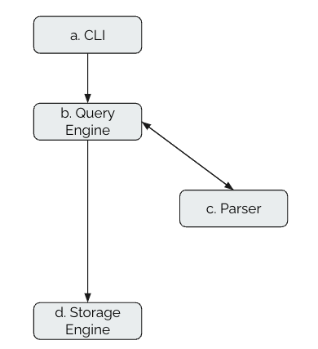
- How to speed insert data I know from Oracle is that they insert data in a temporary place both in RAM and on disk and do housekeeping on periodic basis, the database engine is busy all the time optimizing its structure but in the same time we do not want to lose data in case of power failure of something like that. so try to keep data in this temporary place with no sorting, append your original storage, and later on when system is free resort your indexes and clear the temp area when done
Components
- CLI
- Query Parser
- Query Engine
- Storage Engine

1. Command Line Interface
In the CLI loop, we call the query engine doQuery or doUpdate function based on the SQL query’s prefix keyword. Yes, it is pretty naive :).
The query engine abstracts all the downstream interactions. Query Engine internally calls Parser to parse the SQL statements and convert it to Domain objects. The Domain Objects are then used by the Query Planner to create a query execution plan based on some rules or heuristics. The Query Plan is executed by the Execution Engine. The Execution engine talks to Storge Engine by scanning disk files and reading the table records. These records are then send back to Query Engine via Iterator Pattern. The Query Engine applies filters based on Selection and Projection Operators defined in the Query Plan and finally sends it back to the CLI for printing the table output.
// TinyDbCli.java
private static void cliLoop(IQueryEngine qe) {
Scanner scanner = new Scanner(System.in).useDelimiter(";");
TablePrinter tablePrinter = new TablePrinter();
while (true) {
System.out.print("tinysql> ");
String sql = scanner.next().replace("\n", " ").replace("\r", "").trim();
TableDto result;
if (sql.startsWith("exit")) {
break;
} else if (sql.startsWith("select")) {
result = qe.doQuery(sql);
} else {
result = qe.doUpdate(sql);
}
if (result.message.isEmpty()) {
tablePrinter.print(result);
} else {
System.out.println(result.message);
}
}
scanner.close();
}
}

2. Parser
This layer will parse SQL, tokenize the inputs, create the domain object, and send it to the next layer, ie Query Engine. Our parser currently supports SELECT, CREATE , INSERT , DELETE , UPDATE & DROP .

We are using the pre-compiled MySQL ANTLR parser from Apache ShardingSphere (Kudos to the community!).
<dependency>
<groupId>org.apache.shardingsphere</groupId>
<artifactId>shardingsphere-sql-parser-mysql</artifactId>
<version>5.2.1</version>
</dependency>
The SQL query after being parsed is converted to Domain Objects.
// SQL: SELECT AGE,NAME FROM STUDENTS WHERE AGE=18;
// AGE,NAME -> Fields
// STUDENTS -> Table
// AGE=18 -> Predicate
@ToString
public class QueryData {
private List<String> fields;
private String table;
private A_Predicate pred; // Predicate is a Boolean combination of terms.
}
- A predicate is a boolean combination of terms. (A=18), (B=19)
- A term compares 2 expressions ( ie LHS and RHS) for equality (A=18)
- The expression corresponds to SQL expressions A, 18
- The constant denotes values stored in the database: 18/"Bob"
// SQL : INSERT INTO STUDENTS (NAME, AGE) VALUE ("Bob", 18)
// tblName -> STUDENTS
// flds -> NAME, AGE
// vals -> "Bob", 18
@ToString
public class InsertData {
private String tblname;
private List<String> flds;
private List<D_Constant> vals;
}

We have used the MySQL Dialect here. Using the Lexer and Parser we convert the SQL statements to the Domain objects, which will be used by the query engine.
// MySqlParser.java
public class MySqlParser implements IParser {
MySqlStatementVisitor sqlStatementVisitor;
public MySqlParser(String sql) {
MySQLLexer lexer = new MySQLLexer(CharStreams.fromString(sql));
MySQLStatementParser parser = new MySQLStatementParser(new CommonTokenStream(lexer));
sqlStatementVisitor = new MySqlStatementVisitor(parser);
sqlStatementVisitor.visit(parser.execute());
}
// Returns a QueryData Domain Object
@Override
public QueryData queryCmd() {
return (QueryData) sqlStatementVisitor.getValue();
}
// Object can be of type DeleteData, ModifyData, InsertData etc.
@Override
public Object updateCmd() {
return sqlStatementVisitor.getValue();
}
}
A simple example of how the ANTLR visitor patternworks is shown below. You can add a custom visitXXX() implementation depending on which fields (from the SQL) you want to extract for creating a domain object.
// MySqlStatementVisitor.java
// The ANTLR visitor class for Parsing SQL Statements.
public class MySqlStatementVisitor extends MySQLStatementBaseVisitor {
private final MySQLStatementParser parser;
private COMMAND_TYPE commandType;
private String tableName;
// Populate COMMAND TYPE
@Override
public Object visitCreateIndex(MySQLStatementParser.CreateIndexContext ctx) {
commandType = COMMAND_TYPE.CREATE_INDEX;
return super.visitCreateIndex(ctx);
}
@Override
public Object visitCreateTable(MySQLStatementParser.CreateTableContext ctx) {
commandType = COMMAND_TYPE.CREATE_TABLE;
return super.visitCreateTable(ctx);
}
// Populate TableName
@Override
public Object visitTableName(MySQLStatementParser.TableNameContext ctx) {
this.tableName = ctx.name().getText();
return super.visitTableName(ctx);
}
....
}

3. Query Engine
This layer mainly consists of 3 parts
- Query Optimizer (Finds the JOIN cost and creates an optimal query plan)
- Execution Engine (Interacts with Storage engine using Read/Write or ReadOnly scans)
- Catalog/Metadata Manager (Holds the table schema information)

3.a Query Optimizer
This layer is responsible for calculating JOIN cost and finding an optimal query-plan to fetch data from the underlying Storage Engine.
The Optimizer (in Oracle), Query Optimizer (in SQL Server, MySQL), or Query Planner (in PostgreSQL) translates the SQL statement to an execution plan.
There are generally two kinds of Optimizers:
1. Rule-Based Optimizer (RBO): Rule-Based Optimizers follow a strict set of rules to create an execution plan — e.g., always use an index if possible.
2. Cost-Based Optimizer (CBO): Cost-Based Optimizers generate many different execution plans, apply a cost model to all of them and select the one with the best cost value for execution.
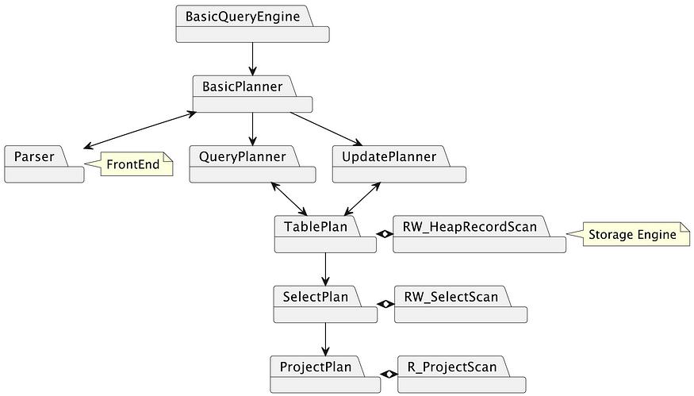

Basic Query Engine
The Query Engine has 2 main functions, doQuery, and doUpdate (we invoked them in the CLI code).The QueryEngine’s code simply invokes the BasicPlanner createQueryPlan or executeUpdate and prints .
//BasicQueryEngine.java
public TableDto doQuery(String sql) {
// Call Planner
Transaction tx = newTx();
Plan p = planner.createQueryPlan(sql, tx);
// Print the result
RORecordScan s = p.open();
List<String> columnNames = p.schema().fields();
List<List<String>> rows = new ArrayList<>();
while (s.next()) {
List<String> row = new ArrayList<>();
for (String field : columnNames)
row.add(s.getVal(field).toString());
rows.add(row);
}
s.close();
tx.commit();
return new TableDto(columnNames, rows);
}
public TableDto doUpdate(String sql) {
// Call Planner
Transaction tx = newTx();
int updatedRows = planner.executeUpdate(sql, tx);
tx.commit();
// Print the result
String message = updatedRows + " " + (updatedRows == 1 ? "row" : "rows") + " updated.";
return new TableDto(message);
}

Basic Planner (Facade Pattern)
BasicPlanner is an abstraction for 2 types of planners, the Query Planner and Update Planner . Depending on the parser’s domain object type, we determine which function to invoke.
//BasicPlanner.java
public BasicPlanner(QueryPlanner queryPlanner, UpdatePlanner updatePlanner) {
this.queryPlanner = queryPlanner;
this.updatePlanner = updatePlanner;
}
public Plan createQueryPlan(String qry, Transaction tx) {
IParser parser = new MySqlParser(qry);
QueryData data = parser.queryCmd();
return queryPlanner.createPlan(data, tx);
}
public int executeUpdate(String cmd, Transaction tx) {
IParser parser = new MySqlParser(cmd);
Object data = parser.updateCmd();
if (data instanceof InsertData) return updatePlanner.executeInsert((InsertData) data, tx);
else if (data instanceof DeleteData) return updatePlanner.executeDelete((DeleteData) data, tx);
else if (data instanceof ModifyData) return updatePlanner.executeModify((ModifyData) data, tx);
else if (data instanceof CreateTableData) return updatePlanner.executeCreateTable((CreateTableData) data, tx);
else if (data instanceof CreateIndexData) return updatePlanner.executeCreateIndex((CreateIndexData) data, tx);
else return 0;
}
We have 2 implementations of Planner here
Basic (Naive: No optimization)
Rule Based (Rule: If the query contains an indexed column, use that index to speed up the Query)
Basic Query Planner
We will now cover the Basic Planner. Rule-based Planner contains minor changes to accommodate the index rule.
The Basic Query Planner mainly uses the 3 items below.
- TablePlan: Read Data from the Storage Engine using Iterator Pattern
- SelectPlan: Filter out the rows based on the predicate condition
- ProjectPlan: Filter out the columns based on fields in the query.
public class BasicQueryPlanner implements QueryPlanner {
private final MetadataMgr mdm; //constructor
public Plan createPlan(QueryData data, Transaction tx) {
//Step 1: Create the plan
Plan p = new A_TablePlan(tx, data.table(), mdm);
//Step 2: Add a selection plan for the predicate
p = new B_SelectPlan(p, data.pred());
//Step 3: Project on the field names
p = new C_ProjectPlan(p, data.fields());
return p;
}
}

Basic Update Planner
This class mainly uses the below 2 classes:
- TablePlan: (RWRecordScan)plan.Open() enables us to read/write data from/to the storage engine.
- MetadataMgr: This is responsible for providing the catalog information (table schema) of a table. .
//BasicUpdatePlanner.java
private final MetadataMgr mdm;//constructor
public int executeCreateTable(CreateTableData data, Transaction tx) {
mdm.createTable(data.tableName(), data.newSchema(), tx);
return 0;
}
public int executeCreateIndex(CreateIndexData data, Transaction tx) {
mdm.createIndex(data.indexName(), data.tableName(), data.fieldName(), tx);
return 0;
}
public int executeInsert(InsertData data, Transaction tx) {
// Step 1: Create a table plan
Plan p = new A_TablePlan(tx, data.tableName(), mdm);
// Step 2: Open the plan in RW mode and seek to the next insert position
RWRecordScan scan = (RWRecordScan) p.open();
scan.seekToInsertStart();
// Step 3: read values from the data (domain object)
// Step 4: Write these values to the RW scan curr position
Iterator<D_Constant> iter = data.vals().iterator();
for (String fldname : data.fields()) {
D_Constant val = iter.next();
scan.setVal(fldname, val);
}
scan.close();
return 1;
}

Plans
Plan class is used to encapsulate relational algebra and the cost (like the number of blocks accessed etc) of operation. The query plan from Query Optimizer, is used to get an efficient physical plan (ie scans) to read data efficiently from the disk.
// TablePlan.java
public A_TablePlan(Transaction tx, String tblname, MetadataMgr md) {
this.tblname = tblname;
this.tx = tx;
recordValueLayout = md.getLayout(tblname, tx);
}
public RORecordScan open() {
// NOTE: The Place where Query Engine interacts with StorageEngine
return new HeapRWRecordScan(tx, tblname, recordValueLayout);
}
public interface Plan {
RORecordScan open();
TableDefinition schema();
int blocksAccessed();
}

// SelectPlan.java
public B_SelectPlan(Plan p, A_Predicate pred) {
this.p = p;
this.pred = pred;
}
public RORecordScan open() {
RORecordScan s = p.open();
return new A_Select_RWRecordScan(s, pred);
}
NOTE: The character prefix A_XX or B_XX etc is used to order the packages and classes.

3. b Execution Engine
The execution engine accesses the required data from the underlying storage system, whether it’s a disk-based file system or an in-memory database. This involves retrieving data from tables, indexes, or other data structures based on the query predicates and JOIN conditions.
For this project, we only have Select and Project Scans inside Execution Engine.

Scans
Upon plan.open() , we get a scan object.

// Select_RWRecordScan.java
public A_Select_RWRecordScan(RORecordScan s, A_Predicate pred) {
this.s = s;
this.pred = pred;
}
public boolean next() {
// NOTE: Row filtering logic
while (s.next()) {
if (pred.isSatisfied(s)) {
return true;
}
}
return false;
}

//Project_RORecordScan.java
public C_Project_RORecordScan(RORecordScan s, List<String> fieldlist) {
this.s = s;
this.fieldlist = fieldlist;
}
public boolean next() {
return s.next();
}
public int getInt(String fldname) {
if (hasField(fldname))
return s.getInt(fldname);
else
throw new RuntimeException("field " + fldname + " not found.");
}
public String getString(String fldname) {
if (hasField(fldname))
return s.getString(fldname);
else
throw new RuntimeException("field " + fldname + " not found.");
}
//NOTE: Column filtering logic
// Called in BasicQueryEngine --> doQuery()
public D_Constant getVal(String fldname) {
if (hasField(fldname))
return s.getVal(fldname);
else
throw new RuntimeException("field " + fldname + " not found.");
}

3. c Catalog Manager
This mainly contains
- Index Manager (responsible for giving index information)
- Stats Manager (responsible for maintaining stats like the number of blocks accessed etc, which can be used for heuristic cost analysis)
- Table Manager (responsible for providing table schema information)

Table Definition (Logical Layout)
The Table definition contains information like
- field names,
- field types,
- and the length of the fields (in the case of VARCHAR)
@ToString
public class TableDefinition {
private final List<String> fields = new ArrayList<>();
private final Map<String, FieldInfo> info = new HashMap<>();
public void addField(String fldname, int type, int length) {
fields.add(fldname);
info.put(fldname, new FieldInfo(type, length));
}
public void addIntField(String fldname) {
addField(fldname, INTEGER, 0);
}
public void addStringField(String fldname, int length) {
addField(fldname, VARCHAR, length);
}
}

Table Physical Layout (Physical Layout)
Structure to hold the Physical layout (Byte Offset) of the records. It also contains the slot size, which is the number of bytes required for a row. We are using fixed-size slot sizes for simplicity, ie even VARCHAR will have a fixed length.
public class TablePhysicalLayout {
private TableDefinition tableDefinition;
private Map<String, Integer> offsets;
private int slotsize;
}

Table Manager
It is responsible for storing information about the tables.
Let's take an example SQL here, which creates a table T1.
create table T1 ( A int, B varchar(9) );
> 0 rows updated.
insert into T1 (A, B) values (1, 'Alice');
> 1 row updated.
insert into T1 (A, B) values (2, 'Bob');
> 1 row updated.
select A,B from T1;
>
+---+-------+
| a | b |
+---+-------+
| 1 | Alice |
| 2 | Bob |
+---+-------+
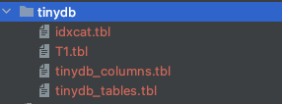
The database creates 2 internal tables for holding metadata about the user tables. It is similar to the information_schema.
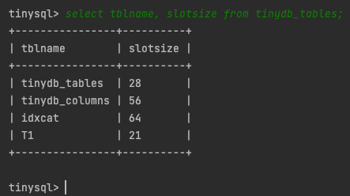
Database file structure
Files: In our design, we create a new file per table and index. So T1, tinydb_columns, and tinydb_tables have their own file.

tinydb_tables

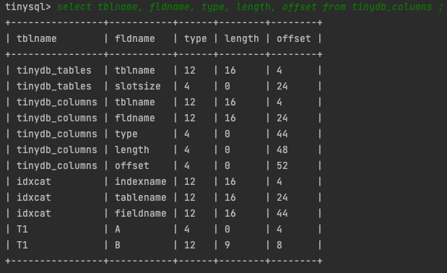
tinydb_columns

public class TableMgr {
// The max characters a tablename or fieldname can have.
public static final int MAX_NAME = 16;
private TablePhysicalLayout tcatRecordValueLayout, fcatRecordValueLayout;
// Register a new table having the specified name and schema.
// It updates tinydb_tables.tbl and tinydb_columns.tbl
public void createTable(String tblname, TableDefinition sch, Transaction tx) {
TablePhysicalLayout recordValueLayout = new TablePhysicalLayout(sch);
// write to tinydb_tables.tbl file
HeapRWRecordScan tcat = new HeapRWRecordScan(tx, "tinydb_tables", tcatRecordValueLayout);
tcat.seekToInsertStart();
tcat.setString("tblname", tblname);
tcat.setInt("slotsize", recordValueLayout.slotSize());
tcat.close();
// write to tinydb_columns.tbl file
HeapRWRecordScan fcat = new HeapRWRecordScan(tx, "tinydb_columns", fcatRecordValueLayout);
for (String fldname : sch.fields()) {
fcat.seekToInsertStart();
fcat.setString("tblname", tblname);
fcat.setString("fldname", fldname);
fcat.setInt("type", sch.type(fldname));
fcat.setInt("length", sch.length(fldname));
fcat.setInt("offset", recordValueLayout.offset(fldname));
}
fcat.close();
}
// Retrieve the layout of the specified table from the catalog
public TablePhysicalLayout getLayout(String tblname, Transaction tx) {
// **Step1**: Read from tinydb_tables.tbl
int size = -1;
HeapRWRecordScan tcat = new HeapRWRecordScan(tx, "tinydb_tables", tcatRecordValueLayout);
// [tableName1, slotsize1] | [tableName2, slotsize2] | [tableName3, slotsize3]
while (tcat.next()) {
if (tcat.getString("tblname").equals(tblname)) {
size = tcat.getInt("slotsize");
break;
}
}
tcat.close();
// **Step 2**: Read from tinydb_columns.tbl
TableDefinition sch = new TableDefinition();
Map<String, Integer> offsets = new HashMap<String, Integer>();
HeapRWRecordScan fcat = new HeapRWRecordScan(tx, "tinydb_columns", fcatRecordValueLayout);
// [tableName1, A, int, 4, offset] | [tableName1, B, varchar, 9, offset] | [tableName3, fldname, type, length offset]
while (fcat.next()) {
if (fcat.getString("tblname").equals(tblname)) {
String fldname = fcat.getString("fldname");
int fldtype = fcat.getInt("type");
int fldlen = fcat.getInt("length");
int offset = fcat.getInt("offset");
offsets.put(fldname, offset);
sch.addField(fldname, fldtype, fldlen);
}
}
fcat.close();
// **Step 3**: Using schema and offset, populate TablePhysicalLayout
return new TablePhysicalLayout(sch, offsets, size);
}
}
}

NOTE: The getLayout() is used insideTablePlan to create RecordScan, which is then used to read data from the storage engine.

Storage Engine
This is a key-value store module that can talk to the underlying file
system and perform CRUD (Create Read Update Delete) operations on database disk files. We are using a Heap Page Organization (ie Data is stored as Blocks without sorting), instead of the traditional B+Tree Page Organization. Since we create a B+Tree index on top of the Heap based data block, we get good-enough performance.
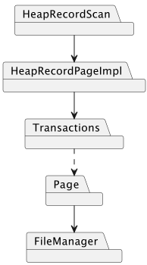
The disk-based B+Tree index will have
- Key : Column value
- Value: RecordId (Contains BlockID & Offset within the Block).

Different DBMS manage pages on disk files in different ways.
- Heap File Organization (Our Approach)
- Tree File Organization (Sorted order tree)
- Sorted File Organization (SST)
- Hashing File Organization
The overall storage engine flow is as below

- It starts with HeapRecordScan (the facade Iterable API)
- If the records are stored in a Page layout, we will use HeapRecordPageImpl to iterate through Page entries. (Page is of fixed size say 4KB. Multiple smaller records/rows will be stored inside a Page)
- HeapRecordPageImpl will pass BlockId and relevant data to the Transactions to interact with the buffer pool.
In our case, we are not using Buffer Pool and hence there is no Page pinning.
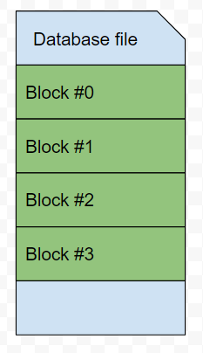
- Transactions will then call File/Disk Manager by passing BlockId and Page. Page internally holds a ByteBuffer for reading and writing bytes.

Components
The storage engine mainly contains
- the data module
- the index module

Data Module
The data module mainly covers the data persistence layer of the database.
  - Block Id
  - HeapRecordScan
The data is stored inside a database file in the form of fixed-sized Blocks. It is read into the memory in the form of Page. BlockId represents a unique identifier to read a file block.
public class BlockId {
private final String fileName;
private final int blockNumber;
}
- HeapRecordScan
We have interfaces for RO and RW Record scans.
// The interface implemented by all query scan.
public interface RORecordScan {
// Position the scan before the first record. Subsequent
// call to next() will return the first record.
public void seekToQueryStart();
// Move the scan to the next record.
public boolean next();
// Use getters to read the feild values
public int getInt(String fldname);
public String getString(String fldname);
public D_Constant getVal(String fldname);
public boolean hasField(String fldname);
public void close();
}

// The interface implemented by all updatable scans.
public interface RWRecordScan extends RORecordScan {
// Seek to the next insert position in the file.
public void seekToInsertStart();
// Return the id of the current record.
public RecordKey getRid();
// Position the scan so that the current record having the specified id.
public void seekTo(RecordKey recordKey);
// Use setters to set the values
public void setVal(String fldname, D_Constant val);
public void setInt(String fldname, int val);
public void setString(String fldname, String val);
public void delete();
}

The concrete implementation of RWRecordScan is shown below in HeapRWRecordScan.
// Provides the enumeration (iterator) for records stored in the Disk.
public class HeapRWRecordScan implements RWRecordScan {
private final Transaction tx;
private final TablePhysicalLayout recordValueLayout;
private HeapRecordPageImpl rp;
private final String filename;
private int currentSlot;
public HeapRWRecordScan(Transaction tx, String tblname, TablePhysicalLayout recordValueLayout) {
this.tx = tx;
this.recordValueLayout = recordValueLayout;
filename = tblname + ".tbl";
if (tx.blockCount(filename) == 0) {
createAndMoveToNewBlock();
} else {
moveToBlock(0);
}
}
// Move to 0th Block
public void seekToQueryStart() {
moveToBlock(0);
}
// currentSlot maintains last read/write position.
public void seekToInsertStart() {
currentSlot = rp.insertAfter(currentSlot);
while (currentSlot < 0) {
if (atLastBlock()) {
createAndMoveToNewBlock();
} else {
moveToBlock(rp.getBlockId().getBlockNumber() + 1);
}
currentSlot = rp.insertAfter(currentSlot);
}
}
// Move to a new slot within the Block
// If it is the last block, return false.
public boolean next() {
this.currentSlot = rp.findSlotAfter(this.currentSlot);
while (currentSlot < 0) {
if (atLastBlock()) {
return false;
}
moveToBlock(rp.getBlockId().getBlockNumber() + 1);
this.currentSlot = rp.findSlotAfter(this.currentSlot);
}
return true;
}
public void delete() {
rp.delete(currentSlot);
}
...
public void setInt(String fldname, int val) {
rp.setInt(currentSlot, fldname, val);
}
...
public int getInt(String fldname) {
return rp.getInt(currentSlot, fldname);
}
}

2. HeapRecordPageImpl
This class is used inside HeapRWRecordScan. This class is used to read a single block (using BlockId) and read the records within that block. This class passes BlockId, Field Position, and Payload to the Transaction class from reading and writing records.
public class HeapRecordPageImpl {
public static final int EMPTY = 0, USED = 1;
private Transaction tx;
private BlockId blockId;
private TablePhysicalLayout recordValueLayout;
public HeapRecordPageImpl(Transaction tx, BlockId blockId, TablePhysicalLayout recordValueLayout) {
this.tx = tx;
this.blockId = blockId;
this.recordValueLayout = recordValueLayout;
}
public int findSlotAfter(int slot) {
return searchAfter(slot, USED);
}
public int insertAfter(int slot) {
int newslot = searchAfter(slot, EMPTY);
if (newslot >= 0) {
setFlag(newslot, USED);
}
return newslot;
}
...
public int getInt(int slot, String fldname) {
int fldpos = offset(slot) + recordValueLayout.offset(fldname);
return tx.getInt(blockId, fldpos);
}
...
// Store an integer at the specified field of the specified slot.
// Here slot is the recordIdx within the Block.
public void setInt(int slot, String fldname, int val) {
int fldpos = offset(slot) + recordValueLayout.offset(fldname);
tx.setInt(blockId, fldpos, val);
}
...
public void delete(int slot) {
setFlag(slot, EMPTY);
}
...
}

3. Transaction
Ideally, the transaction should have commit(), pin(), etc. But to make things simple, we are ignoring it in the current version. Transaction internally uses Page object to read and write to/from the file manager.
public class Transaction {
private static int nextTxNum = 0;
private FileMgr fm;
public Transaction(FileMgr fm) {
this.fm = fm;
txnum = nextTxNumber();
}
// Monotonically increasing Txn Number
private static synchronized int nextTxNumber() {
nextTxNum++;
return nextTxNum;
}
...
public synchronized int getInt(BlockId blk, int offset) {
Page contents = new Page(fm.blockSize());
fm.read(blk, contents);
return contents.getInt(offset);
}
...
public synchronized void setInt(BlockId blk, int offset, int val) {
Page contents = new Page(fm.blockSize());
fm.read(blk, contents);
contents.setInt(offset, val);
fm.write(blk, contents);
}
}
4. Page
Page is the in-memory representation of a Block saved in the Disk. We use it to read and update block data.
public class Page {
public static Charset CHARSET = StandardCharsets.US_ASCII;
private ByteBuffer bb;
public Page(int blocksize) {
bb = ByteBuffer.allocateDirect(blocksize);
}
...
...
public String getString(int offset) {
byte[] b = getBytes(offset);
return new String(b, CHARSET);
}
...
private ByteBuffer contents() {
bb.position(0);
return bb;
}
}
public int getInt(int offset) {
return bb.getInt(offset);
}
public void setInt(int offset, int n) {
bb.putInt(offset, n);
}
public byte[] getBytes(int offset) {
bb.position(offset);
int length = bb.getInt();
byte[] b = new byte[length];
bb.get(b);
return b;
}

5. File Manager(File Manager is the class responsible for all the File IO.)
public class FileMgr {
private final File dbDirectory;
private final int blockSize;
private final boolean isNew;
public synchronized void read(BlockId blk, Page p) {
try {
RandomAccessFile f = getRandomAccessFile(blk.getFileName());
f.seek((long) blk.getBlockNumber() * blockSize);
f.getChannel().read(p.contents());
f.close();
} catch (IOException e) {
throw new RuntimeException("cannot read block " + blk);
}
}
public synchronized void write(BlockId blk, Page p) {
try {
RandomAccessFile f = getRandomAccessFile(blk.getFileName());
f.seek((long) blk.getBlockNumber() * blockSize);
f.getChannel().write(p.contents());
f.close();
} catch (IOException e) {
throw new RuntimeException("cannot write block" + blk);
}
}
public int blockCount(String filename) {
try {
RandomAccessFile f = getRandomAccessFile(filename);
int result = (int) (f.length() / blockSize);
f.close();
return result;
} catch (IOException e) {
throw new RuntimeException("cannot access " + filename);
}
}
}

Index Module
The index implemented on top of the Heap File Organization helps in improved performance, if the query uses an indexed column.
public interface RWIndexScan {
public void insert(D_Constant key, RecordKey value);
public void delete(D_Constant key, RecordKey value);
// Iterator
public void seek(D_Constant key);
public boolean hasNext();
public RecordKey next();
public void close();
}
@Override
public void insert(D_Constant key, RecordKey value) {
tree.insert(key, value);
}
@Override
public void seek(D_Constant key) {
iterator = tree.find(key).iterator();
}
@Override
public boolean hasNext() {
return iterator.hasNext();
}
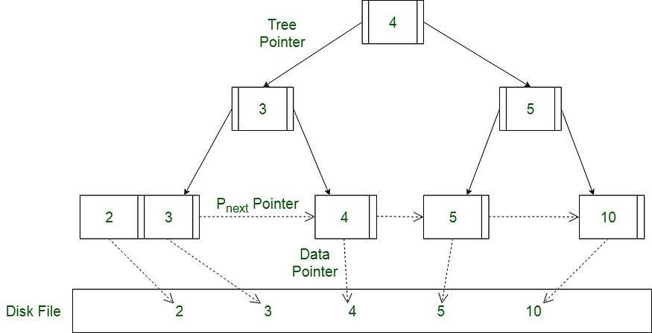
// B+ tree index using https://github.com/davidmoten/bplustree
public class BPlusTreeIndex implements RWIndexScan {
BPlusTree<D_Constant, RecordKey> tree;
Iterator<RecordKey> iterator;
public AdvancedBPlusTreeIndex() {
tree = BPlusTree.file().directory("tinydb").maxLeafKeys(32)
.maxNonLeafKeys(8)
.segmentSizeMB(1)
.keySerializer(new ConstantSerializer())
.valueSerializer(new RecordKeySerializer())
.naturalOrder();
}
@Override
public RecordKey next() {
return iterator.next();
}
@SneakyThrows
@Override
public void close() {
tree.close();
}
}

Result
create table T2 ( A int, B varchar(9) );
create index A_IDX on T2(A);
insert into T2 (A, B) values (1, 'Alice');
insert into T2 (A, B) values (2, 'Bob');
select A,B from T2;
>
+---+-------+
| a | b |
+---+-------+
| 1 | Alice |
| 2 | Bob |
+---+-------+
select A,B from T2 where A=1;
> index on a used
+---+-------+
| a | b |
+---+-------+
| 1 | Alice |
+---+-------+
exit;

